**THE YYTERI**

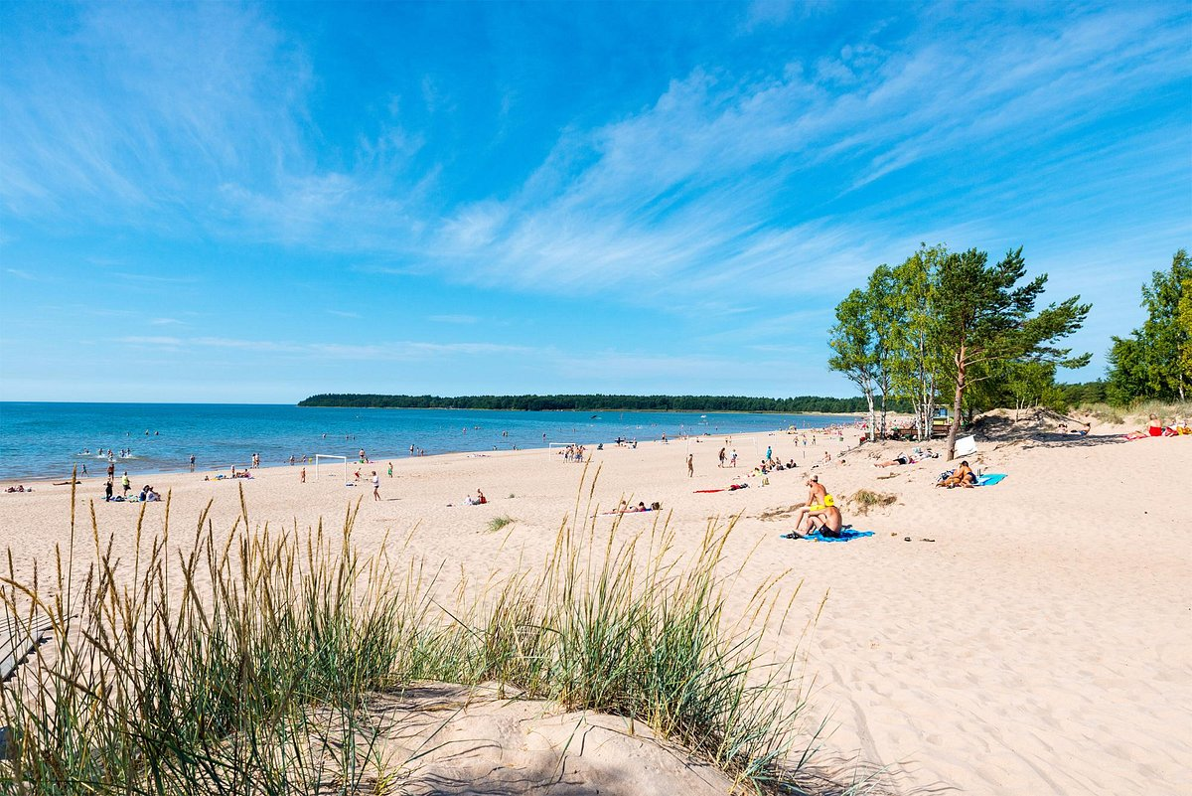**Yyteri** is a district and a beach in the city of [Pori](https://en.wikipedia.org/wiki/Pori), Finland. It is located about 17 kilometres (11 mi) from the centre, bordering the [Baltic Sea](https://en.wikipedia.org/wiki/Baltic_Sea). The distance from [Helsinki](https://en.wikipedia.org/wiki/Helsinki) to Yyteri is about 260 kilometres (160 mi) and it takes more than three hours to get there by car mainly along [Highway 2](https://en.wikipedia.org/wiki/Finnish_national_road_2). Yyteri is not an urban district, instead it is mostly like a [holiday resort](https://en.wikipedia.org/wiki/Holiday_resort).